**ASCENSION LUTHERAN CHURCH**

**THE LUTHERAN CHURCH—MISSOURI SYNOD**

**LITTLETON, COLORADO**

***April 3 and 4, 2021***

**5 p.m. Saturday and 8:00, 9:30, & 11 a.m. Sunday**

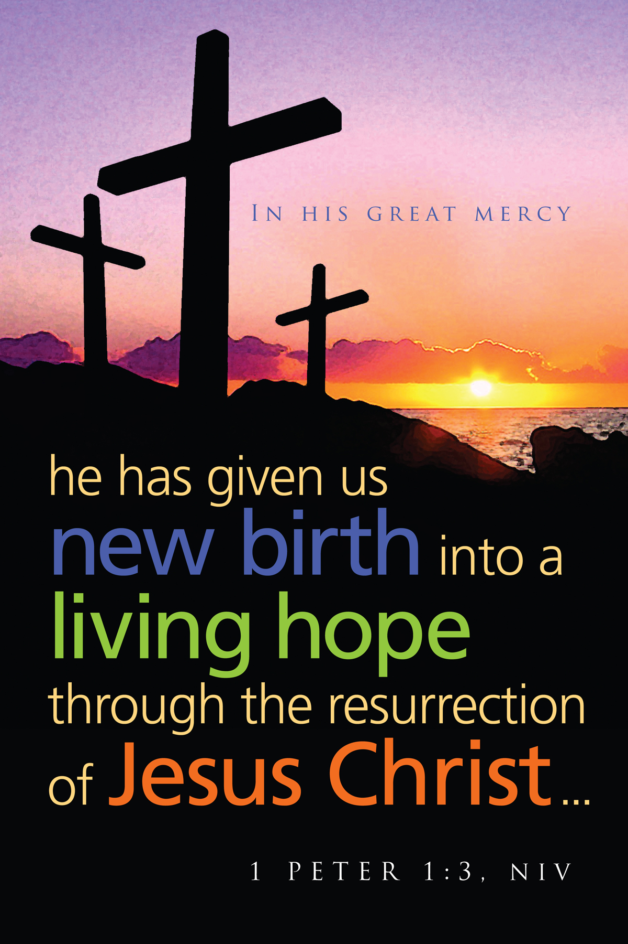



**THE RESURRECTION OF OUR LORD—EASTER DAY**

He is Risen, Indeed! You Are Risen, Indeed!

**AS WE GATHER**

**Death is our common enemy. But God has chosen to do battle with our enemy and has given to all the same victory won by Jesus Christ. The veil of death cast over all is now removed in Christ Jesus. Death and all its terror and power has been answered by the resurrection of Jesus once for all. We participate in this victory in the banquet our Lord has prepared, first in the Holy Communion of His crucified and risen flesh and blood, and then in the marriage feast of the Lamb, which has no end. Though for now we wait by faith for Him to bring to consummation all things, we wait as a people saved by His blood and marked for everlasting life. So let us be glad and rejoice in His salvation!**

**✠ PREPARATION ✠**

**PRESERVICE MUSIC**

“Christ Jesus Lay in Death’s Strong Bands” J.S. Bach

“Good Christian Friends, Rejoice and Sing” Paul Manz

“Jesus Priceless Treasure” Paul Manz

“Praise to the Lord the Almighty” ***(8 and 9:30 a.m. ONLY!)*** arr. Gaide

Diana Gaide, pianist

**PRELUDE** “Jesus Christ is Risen Today” Robert Hobby

**GREETING**

**OPENING HYMN** “Now All the Vault of Heaven Resounds” *LSB* 465

**(Verses 1-2, 4)**

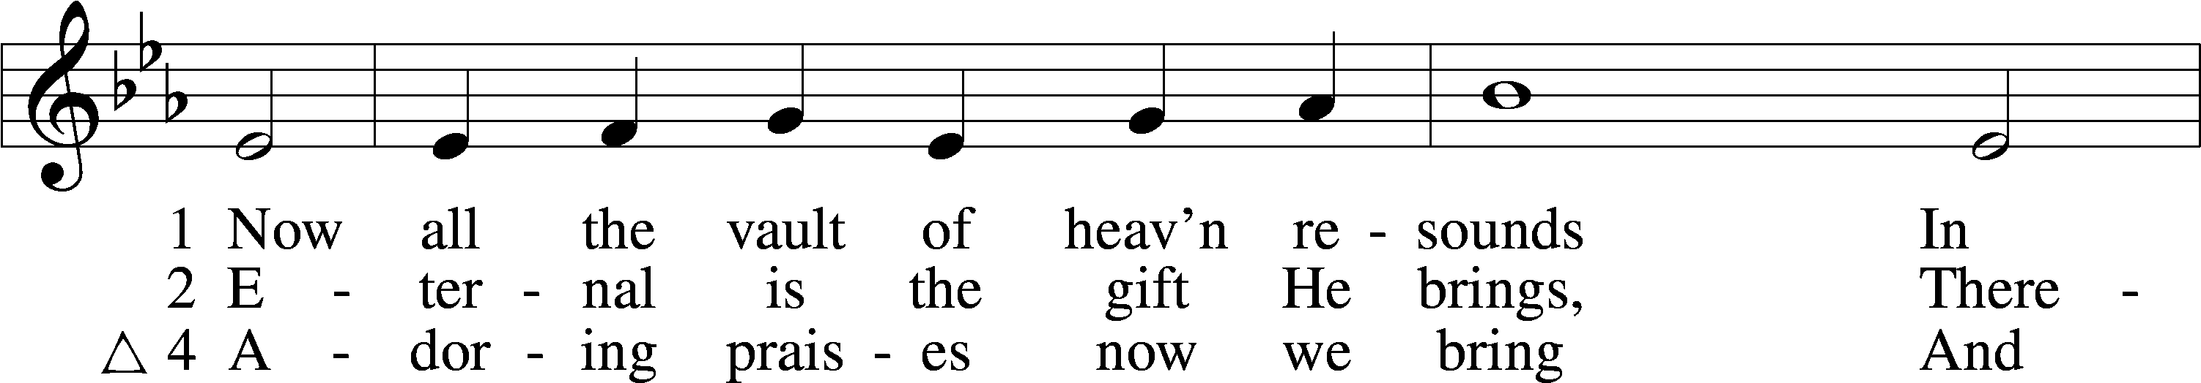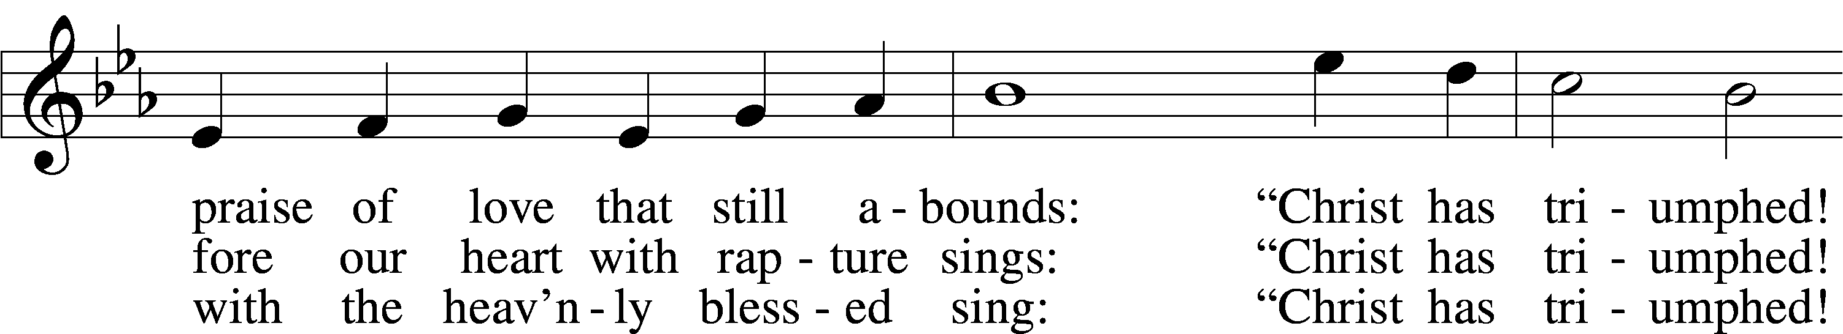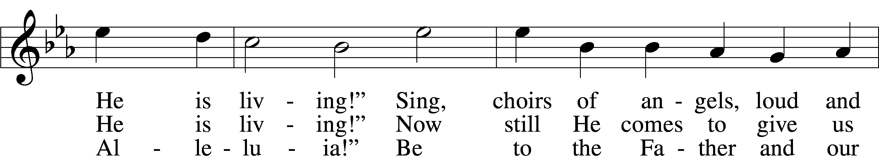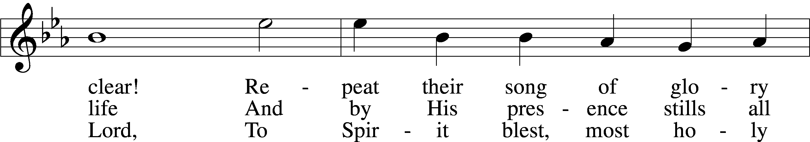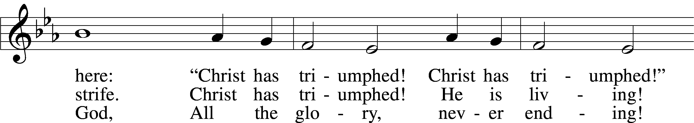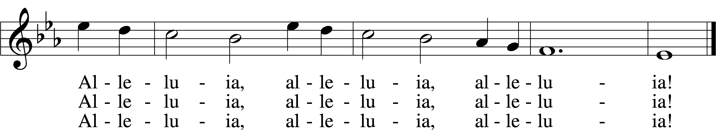

Text: © 1958 Augsburg Publishing House. Used by permission: LSB Hymn License no. 110000713

Tune: Public domain

**INVOCATION**

Pastor: In the name of the Father and of the ✠ Son and of the Holy Spirit.

**People: Amen.**

**OPENING SENTENCES**

Pastor: Alleluia! Christ is risen!

**People: He is risen indeed! Alleluia!**

Pastor: He died for our sins,

**People: according to the Scriptures.**

Pastor: He was buried in the tomb,

**People: according to the definite plan of God.**

Pastor: He rose from the dead

**People: and appeared to many.**

Pastor: Alleluia! Christ is risen!

**People: He is risen indeed! Alleluia!**

**CONFESSION AND ABSOLUTION**

Pastor: If Christ had not been raised from the dead, we would still be dead in our trespasses and sins. Let us consider our sinfulness and God’s great mercy in Christ.

Pastor: Heavenly Father,

**People: we have sinned against You in our thoughts, words, and actions. We confess our shameful thoughts about our leaders, enemies, and strangers. We confess our shameful words spoken to our families, friends, and colleagues. We confess our sinful actions and thoughts toward our neighbors. For the sake of the risen Christ, forgive us, renew us, and lead us, so that we follow in His footsteps both now and when He returns in glory. Amen.**

Pastor: If Christ had not been raised from the dead, we would still be dead in our trespasses and sins, but Christ rose from the grave, and death no longer has dominion over Him! God did this in accordance with the Scriptures to forgive our sins. As a called and ordained servant of the risen Christ and by His authority, I announce the forgiveness of all your sins in the name of the Father and of the ✠ Son and of the Holy Spirit.

**People: Amen. We look for the resurrection of the dead and the life of the world to come. Amen.**

**KYRIE**



**HYMN OF PRAISE** *arr. Carl Schalk*



**EASTER DRAMA *(9:30 & 11 a.m. ONLY!)*** “Easter Morning”

**(Participants: Nevaeh Cooper, Tenley Erling, Jenna Harvey-Kabelman,**

**Ashlyn Lafferty, Anna Wishon)**



**✠ WORD ✠**

**Epistle: 1 Corinthians 15:1-11**

(Christ appeared to His disciples and to more than five hundred witnesses.)

**Now, brothers, I want to remind you of the gospel I preached to you, which you received and on which you have taken your stand. By this gospel you are saved, if you hold firmly to the word I preached to you. Otherwise, you have believed in vain. For what I received I passed on to you as of first importance: that Christ died for our sins according to the Scriptures, that he was buried, that he was raised on the third day according to the Scriptures, and that he appeared to Peter, and then to the Twelve. After that, he appeared to more than five hundred of the brothers at the same time, most of whom are still living, though some have fallen asleep. Then he appeared to James, then to all the apostles, and last of all he appeared to me also, as to one abnormally born. For I am the least of the apostles and do not even deserve to be called an apostle, because I persecuted the church of God. But by the grace of God I am what I am, and his grace to me was not without effect. No, I worked harder than all of them--yet not I, but the grace of God that was with me. Whether, then, it was I or they, this is what we preach, and this is what you believed.**

Pastor: This is the Word of the Lord.

**People: Thanks be to God.**

*Congregation, please rise for the Gospel.*

**Holy Gospel: Mark 16:1-8**

(He is risen; He is not here!)

Pastor: The Holy Gospel according to Mark, the sixteenth chapter.

**People: Glory to You, O Lord.**

**When the Sabbath was over, Mary Magdalene, Mary the mother of James, and Salome bought spices so that they might go to anoint Jesus' body. Very early on the first day of the week, just after sunrise, they were on their way to the tomb and they asked each other, "Who will roll the stone away from the entrance of the tomb?"**

**But when they looked up, they saw that the stone, which was very large, had been rolled away. As they entered the tomb, they saw a young man dressed in a white robe sitting on the right side, and they were alarmed.**

**"Don't be alarmed," he said. "You are looking for Jesus the Nazarene, who was crucified. He has risen! He is not here. See the place where they laid him. But go, tell his disciples and Peter, `He is going ahead of you into Galilee. There you will see him, just as he told you.' "**

**Trembling and bewildered, the women went out and fled from the tomb. They said nothing to anyone, because they were afraid.**

Pastor: This is the Gospel of the Lord.

**People: Praise to You, O Christ.**

**HYMN OF THE DAY** “Jesus Christ is Risen Today” *LSB* 457

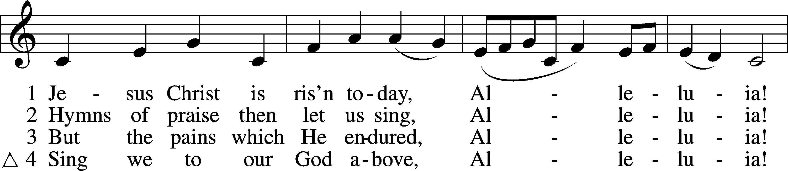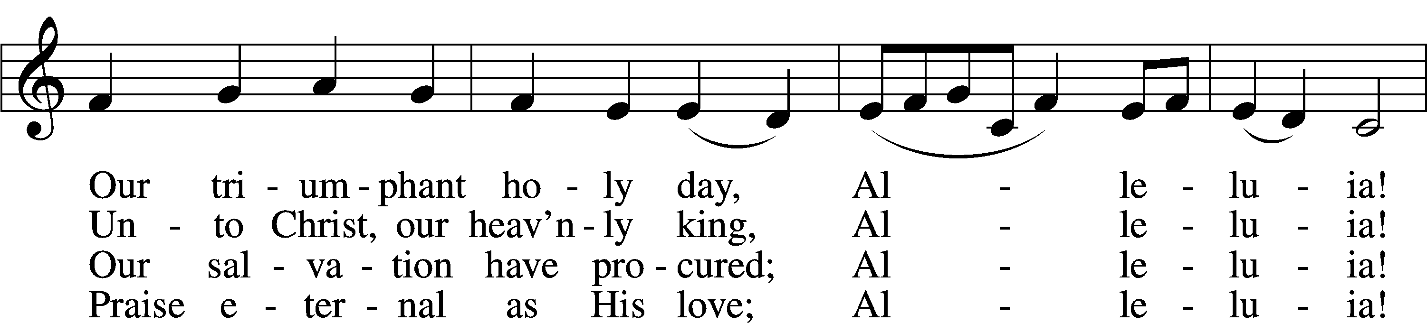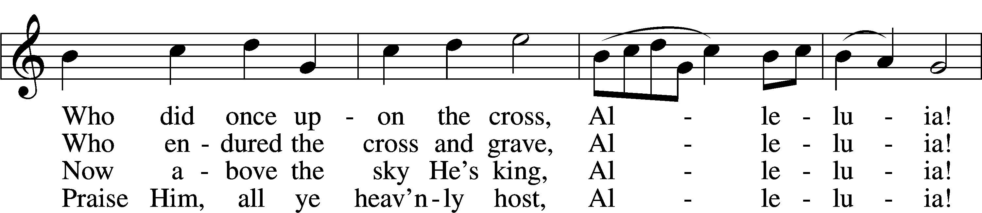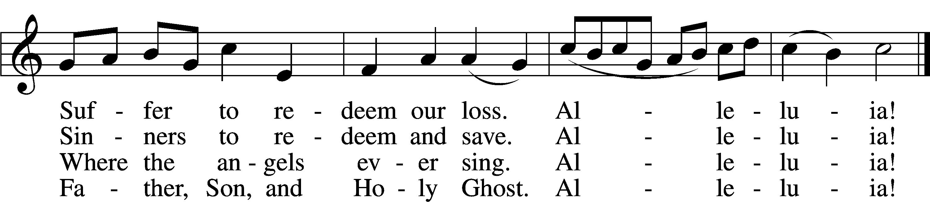

Text and tune: Public domain

**SERMON** “Go!!!”Pastor John Larson

TEXT: Mark 16:1-8

**CREED—**The Second Article with Explanation (Luther’s Catechism)

Pastor Jesus fulfilled all Scripture as the Word made flesh. Forty days after His victory over sin, death, and the devil by His rising from the dead, He ascended into heaven. Believing in Jesus Christ, God’s only Son, as our Lord and Savior and humanity’s redemption and source of all salvation, we focus on the Small Catechism’s explanation of the Second Article of the Apostles’ Creed, which we confess together:

People **And in Jesus Christ, His only Son, our Lord, who was conceived by the Holy Spirit, born of the virgin Mary, suffered under Pontius Pilate, was crucified, died and was buried. He descended into hell. The third day He rose again from the dead. He ascended into heaven and sits at the right hand of God the Father Almighty. From thence He will come to judge the living and the dead.**

Pastor What does this mean?

People **I believe that Jesus Christ, true God, begotten of the Father from eternity, and also true man, born of the virgin Mary, is my Lord,**  
  
 **who has redeemed me, a lost and condemned person, purchased and won me from all sins, from death, and from the power of the devil; not with gold or silver, but with His holy, precious blood and with His innocent suffering and death,**  
  
 **that I may be His own and live under Him in His kingdom and serve Him in everlasting righteousness, innocence, and blessedness,**  
  
 **just as He is risen from the dead, lives and reigns to all eternity.**  
  
 **This is most certainly true.**

**PRAYER OF THE CHURCH**

Pastor: Let us pray for the whole people of God in Christ Jesus and for all people according to their needs.  
  
Heavenly Father, we live in a culture of distractions and diversions. Help us to focus our hearts and minds on the things of first importance: Christ’s death and resurrection for sinners, for Christ is risen!

**People: He is risen indeed! Alleluia!**

Pastor: Lord, You sent a messenger to proclaim Jesus’ resurrection to the women on Easter morning. Inspire us to share the message of Jesus’ resurrection throughout the world, for Christ is risen!

**People: He is risen indeed! Alleluia!**

Pastor: Lord, there are many in this world who have been abused, neglected, and abandoned, suffering at the hands of evil people. Spread Christ’s resurrection victory into their lives of pain and hopelessness. Raise them from darkness into Your light, for Christ is risen!

**People: He is risen indeed! Alleluia!**

Pastor: Lord, send healing and care to all who are sick, injured, and recovering, [*especially* . . . ]. Comfort them with the hope of resurrected bodies that will be ours when Jesus returns, for Christ is risen!

**People: He is risen indeed! Alleluia!**

Pastor: *[Other intercessions may be added here….]* for Christ is risen!

**People: He is risen indeed! Alleluia!**

Pastor: Into Your hands we commend all for whom we pray, trusting in Your mercy, through Jesus Christ, our risen Lord.

**People: Amen.**

**Offering** *Offerings will be collected at the back, in the Narthex.*

**HOLY COMMUNION AT ASCENSION**

*The Lord, our Host, invites to his Supper those who are baptized into the Christian faith, confess him as Savior, have been instructed and have examined themselves, truly repent of sins, believe the Risen Lord is present in the sacrament with his true body and blood, and resolve to live faithfully and obediently. For those with an intolerance to alcohol, the center ring of the tray contains grape juice. Gluten free wafers are available to those with wheat allergies. Children who have not been instructed, yet desire a blessing, are invited to come forward with arms crossed. When receiving the bread and wine, the communicant may respond with “Amen!”, a word of affirmation and belief.*

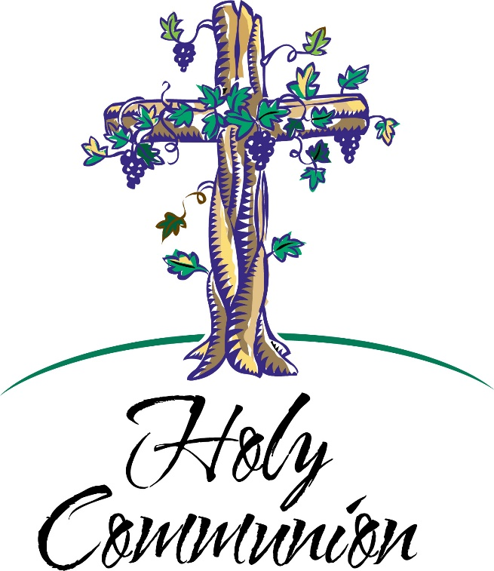

**✠ SACRAMENT ✠**

**PREFACE**

Pastor: The Lord be with you. *2 Timothy 4:22*

**People: And also with you.**

Pastor: Lift up your hearts. *Colossians 3:1*

**People: We lift them to the Lord.**

Pastor: Let us give thanks to the Lord our God. *Psalm 136*

**People: It is right to give Him thanks and praise.**

**PROPER PREFACE**

Pastor: It is truly good, right, and salutary that we should at all times and in all places give thanks to You, holy Lord, almighty Father, everlasting God. And most especially are we bound to praise You on this day for the glorious resurrection of Your Son, Jesus Christ, the very Paschal Lamb, who was sacrificed for us and bore the sins of the world. By His dying He has destroyed death, and by His rising again He has restored to us everlasting life. Therefore with Mary Magdalene, Peter and John, and with all the witnesses of the resurrection, with angels and archangels, and with all the company of heaven we laud and magnify Your glorious name, evermore praising You and singing:

**SANCTUS**

**

**THE WORDS OF OUR LORD** *Matthew 26:26–28; Mark 14:22–24; Luke 22:19–20; 1 Corinthians 11:23–25*

Pastor: Our Lord Jesus Christ, on the night when He was betrayed, took bread, and when He had given thanks, He broke it and gave it to the disciples and said: “Take, eat; this is My ✠ body, which is given for you. This do in remembrance of Me.”  
  
In the same way also He took the cup after supper, and when He had given thanks, He gave it to them, saying: “Drink of it, all of you; this cup is the new testament in My ✠ blood, which is shed for you for the forgiveness of sins. This do, as often as you drink it, in remembrance of Me.”

**LORD’S PRAYER** (*Matthew 6:9–13*)

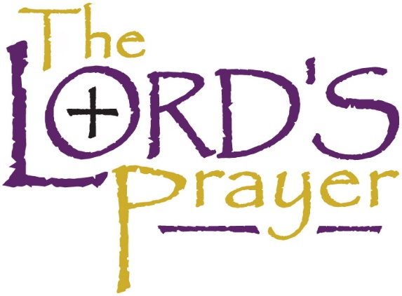**People:** **Our Father who art in heaven, hallowed be Thy name, Thy kingdom come, Thy will be done on earth as it is in heaven; give us this day our daily bread; and forgive us our trespasses as we forgive those who trespass against us; and lead us not into temptation, but deliver us from evil. For Thine is the kingdom and the power and the glory forever and ever. Amen.**

**AGNUS DEI**



**DISTRIBUTION MUSIC**

“I Know that My Redeemer Lives” **(Verses 1-2, 5, 7-8 as indicated below)** *LSB* 461

**Verse 1-2: All**

**Verse 5: Men Only**

**Verse 7: Women Only**

**Verse 8: All**

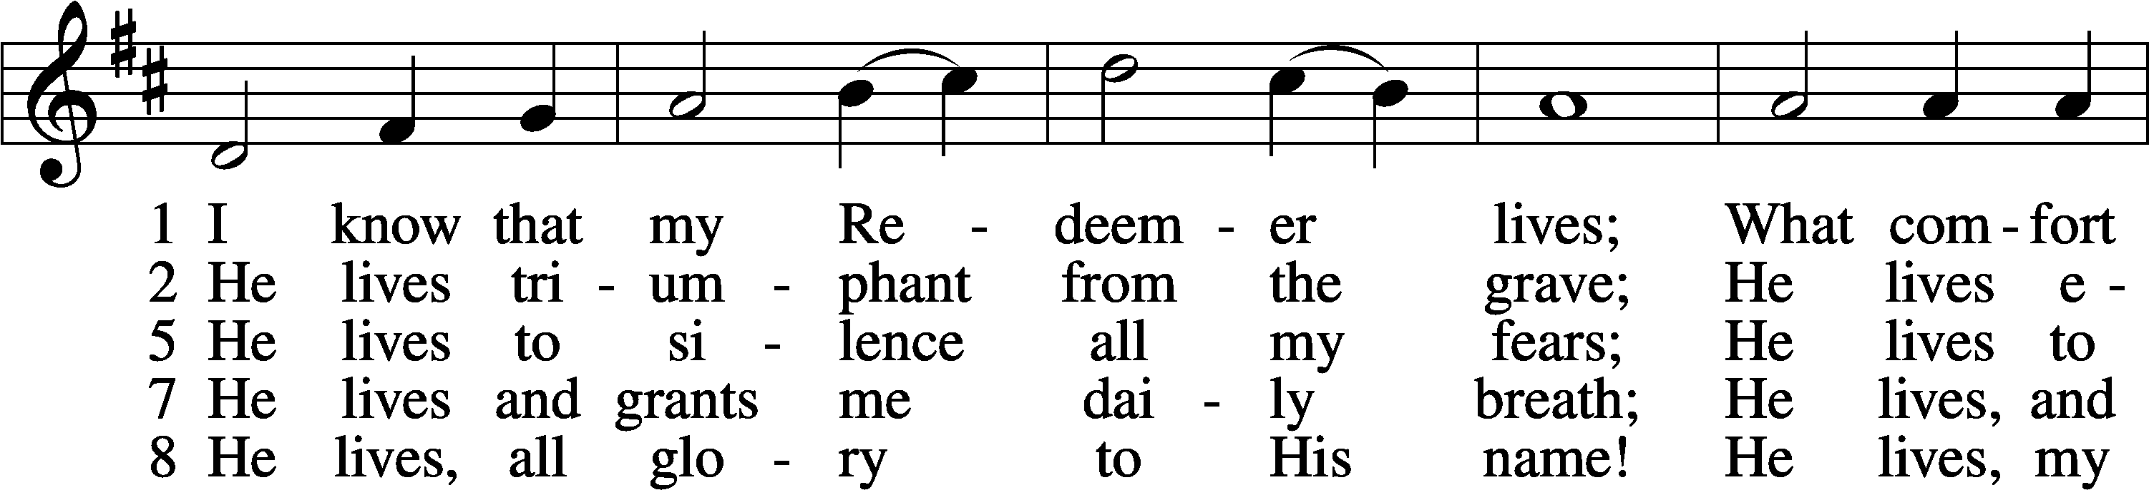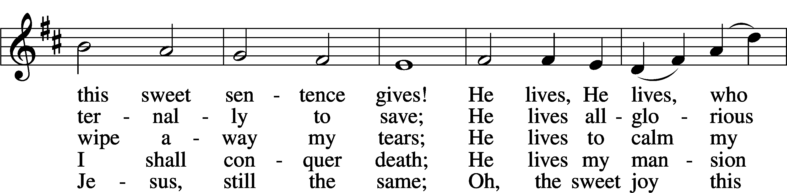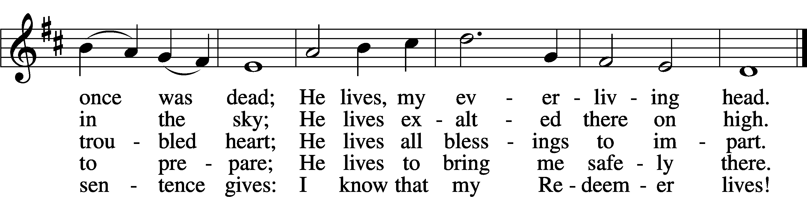

Tune and text: Public domain

“All Creatures of our God and King” ***(8 and 9:30 a.m. ONLY!)*** arr. Dino

Diana Gaide, pianist

Easter Organ Music (As time permits)

**GENERAL COMMUNION BLESSING**

**POST-COMMUNION THANKSGIVING**

Pastor: Let us pray.  
  
 O Lord, You have given us grace this day to hear in our ears the Good News of our Lord’s resurrection and to receive with our lips His crucified and risen body and blood. Grant that by this Holy Communion we be sustained in faith, equipped to fulfill the good purpose of Your love in our daily lives, and be kept holy and blameless until He comes to bring us into the place of everlasting light and life; through Jesus Christ, Your Son, our Lord, who lives and reigns with You and the Holy Spirit, one God, now and forever.

**People: Amen.**

**BENEDICTION**

Pastor: The Lord bless you and keep you.  
The Lord make His face shine on you and be gracious to you.  
The Lord look upon you with favor and ✠ give you peace. *Numbers 6:24–26*

**People: Amen.**

**DISMISSAL**

Pastor: Go in peace! Serve the Lord!

**People: Thanks be to God.**

Pastor: Alleluia! Christ is risen!

**People: He is risen indeed! Alleluia!**

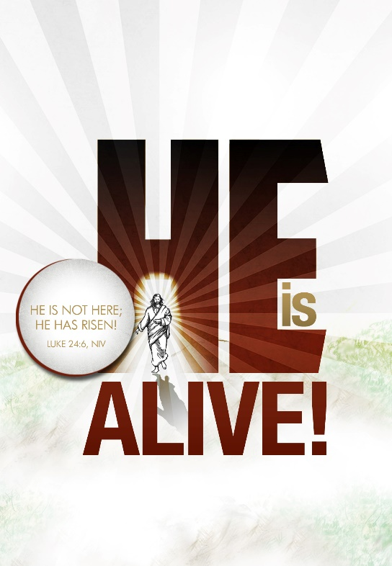

**CLOSING HYMN** “Alleluia, Alleluia! Hearts to Heaven” *LSB* 477

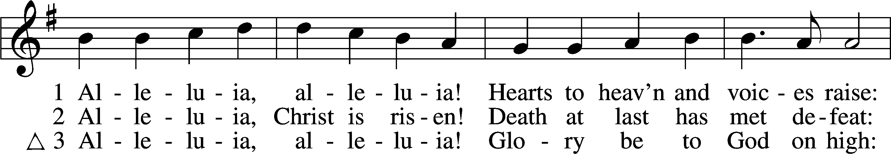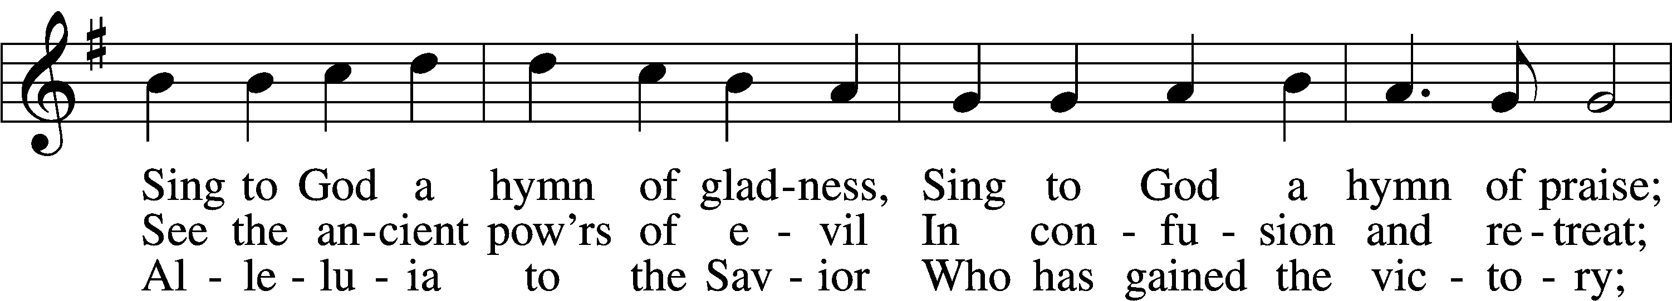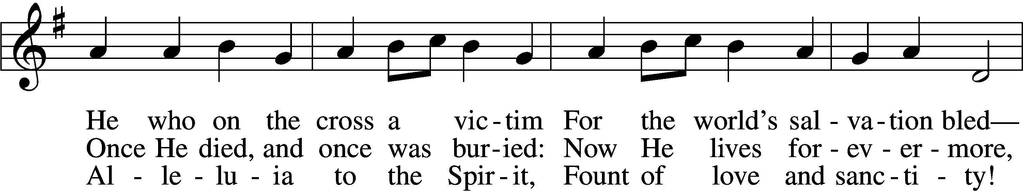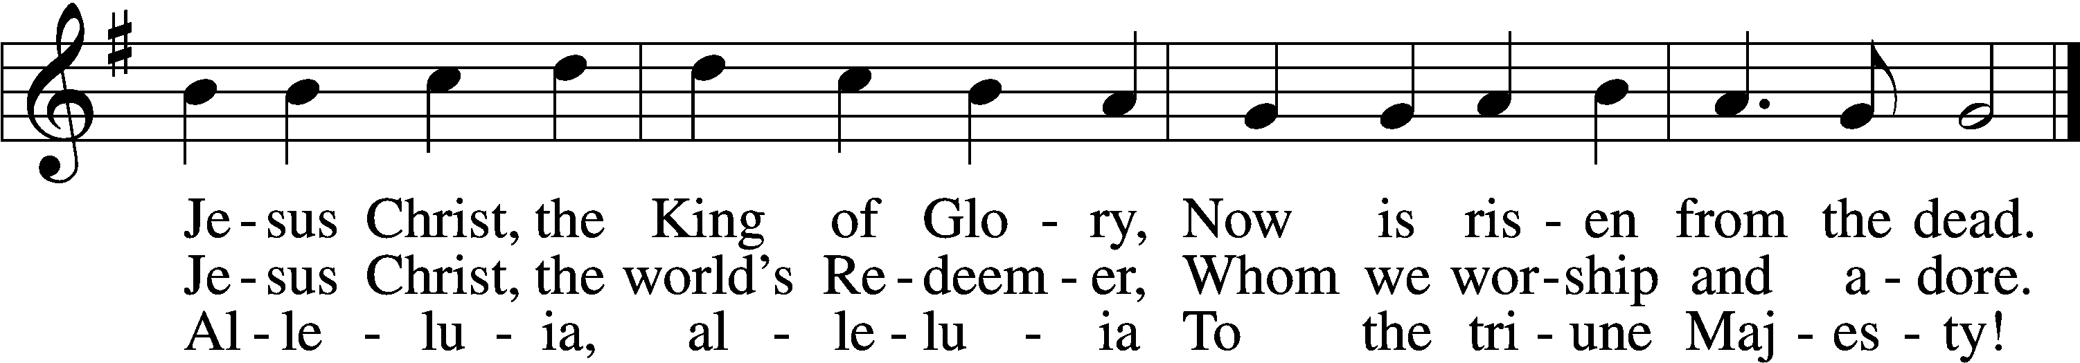

Text (sts. 1, 3) and tune: Public domain

Text (st. 2): © 1982 The Jubilate Group, admin. Hope Publishing Co. Used by permission: LSB Hymn License no. 110000713

**CONGREGATIONAL CONCERNS**

**POSTLUDE** “Jesus Christ, My Sure Defense” Paul Manz

***(Based on LSB 741 and LSB 490)***

**2021 Lilies were given by:**

***Joyce Dowdy***

***Norm & Connie Fringer***

***Don & Marilyn Loptien***

***Dan & Kim McCormick***

***Chuck & Gloria Mielke***

***Crystal Sundet***

**2021 Palms were given by:**

***Pastor John & Marilyn Larson***

***Dan & Kim McCormick***

***Chuck & Gloria Mielke***

***Charlotte Wilkinson***

***THANK YOU!***



**Serving in Worship**

OFFICIANT and CELEBRANT Pastor John Larson

DIRECTOR OF MUSIC MINISTRIES Michael Zehnder

PIANIST Diana Gaide

